**Boolean Algebra Full Marks - 54**

1. **Using Boolean identities, reduce the given Boolean expression: [2]**

**F(X, Y, Z) = X′Y + YZ′ + YZ + XY′Z′**

1. **State and prove Absorption law. [2]**
2. **State and prove Distributive law. [2]**
3. **Verify by using truth Table. [2]**

X + X’Y = X + Y

1. Draw a Logic Circuit diagram for the following Boolean expression: [2 x 2 = 4]
2. (X+Y).(X’+Z’).(Y+Z)
3. A’B’C’D + AB’C’D + ABC’D +ABCD’
4. Derive the Boolean expression for the following logic circuits. [5 x 2 = 10]

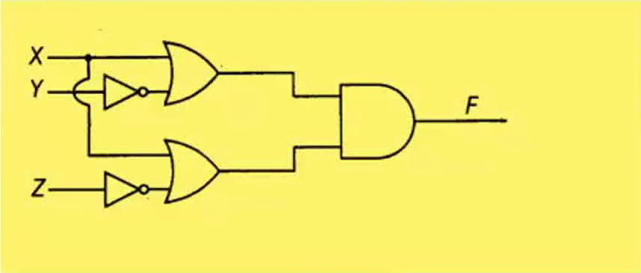

1. Solve the following Boolean expression algebraically also write each law while using it in any step. [6 x 2 = 12]
2. X.Y + Y.Z +Y’.Z = X.Y+Z
3. (X.Y)’ + X’ + XY = X’ +XY +Y’
4. X.Y + X’.Z + Y.Z = X.Y +X’.Z
5. X’.Y’Z’ + X’.Y.Z’ + X.Y’.Z’ + X.Y.Z’ = Z’
6. (A’ + B’) . (A+B) = A’.B + A.B’
7. X’Y’Z’ + X’Y’Z + X’YZ + X’YZ’ + XY’Z’ + XY’Z = X’ + Y’
8. Perform the following conversions/operations: [14 x 1 = 14]
9. (10110.101)₂ = (?)₈
10. (473)₈ = (?)₂
11. (111011.11)₂ = (?)₁₆
12. (CAFE89)₁₆ = (?)₂
13. 1101 – 11 (using 1’s complement)
14. 1101 x 111
15. (27.125)₁₀ = (?)₂
16. (101110.1010)₂ = (?)₁₀
17. 111001 + 1011.11
18. Divide (1001110)₂ by (100)₂
19. (1AB2)₁₆ + (2198)₁₆
20. (B84F)₁₆ - (A53)₁₆
21. (634)₈ + (475)₈
22. (2304)₈ - (1065)₈
23. Verify if : (a => b) V (b => a) = 1 [2]
24. Solve the following Boolean expression using Truth Table. [4 x 2 = 8]
25. XYZ’ + X’Y’Z
26. XY’(Z + YZ’) + Z’
27. A[(B’+C) + C’]
28. (C+D)’ + A’CD’ +AB’C +ACD’